1. Create the following credentials from the AWS account (<https://us-east-1.console.aws.amazon.com/kinesisvideo/home?region=us-east-1#/dashboard>):
   * 1. AWS_ACCESS_KEY
     2. AWS_SECRET_ACCESS_KEY
     3. AWS_KVS_HOST

**Note**: Steps to create the AWS security credentials are explained in section: Create AWS Security Credentials.

1. On opening the AWS_Streaming mobile app, click on the plus sign at the bottom right corner.

Figure 8: AWS_Streaming APP

1. Enter the AWS credentials in the mobile app.

Select the appropriate AWS cloud location using the Select Region drop-down. Enter the Talaria TWO MAC ID in the device Mac field.

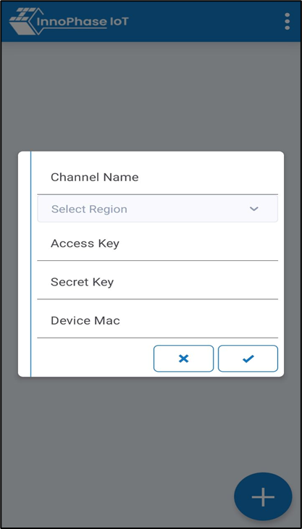

Figure 9: Enter AWS credentials

1. On providing the AWS credentials, the video streaming channel appears in the streaming app listing. Click on the channel to start video streaming.

Figure 10: AWS_Streaming APP - T2_VIDEO

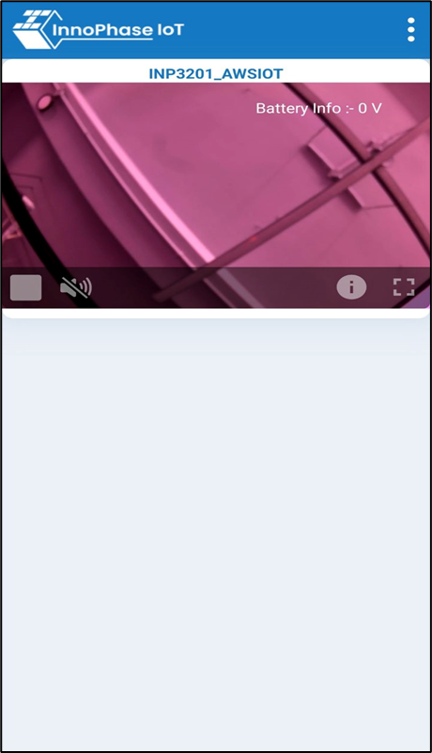

Figure 11: AWS_Streaming app- video streaming